
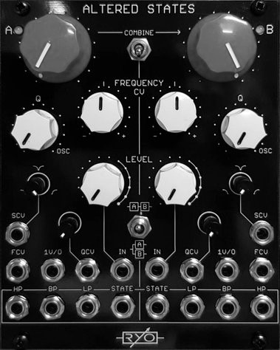

LjunggrenAudio RYO Altered States
Dual State Variable Voltage Controlled Filter

Quickstart – what is the Altered States and how do I get going?

Altered States is a dual analogue state variable filter in a 20hp module. The filter cores are 12db/Oct and based around the clean and reliable 2164 Quad VCA chipset and offers full voltage control over cutoff frequency and resonance as well as individual outputs for each filter response, including a variable state output with manual as well as voltage control.

Installation

To begin installation, please make sure that:
- you have a standard pinout eurorack bus board
- you have +12V and -12V power rails on that bus board [no +5V supply is required]
- the power rails are not overloaded

!!!Before installing this module disconnect the power from your system!!!

- Double check the polarity of the ribbon cable - The red stripe should be aligned with the -12V rail, on both the module and on the bus board

[we use shrouded headers but it's still possible a cable has been assembled with the stripe on the wrong side of the shroud so always double check!].

Also make sure when using busboards without shrouded headers that the pins aren't transposed a row vertically or horizontally – all pins should insert into holes on the cable.

Although we use both PTC fuses and schottky diodes to provide reverse polarity and excess current protection, we do not take any responsibility for damages caused by wrong power supply connection!

After you have connected everything, double checked it and ensured your case is closed such that no power lines can be touched by your hand or any stray cables drop into holes, turn on your system and test the module.

The Altered States is a high skill-level project, it has a large parts count and multiple PCBs, and hence requires significantly more than basic experience in PCB soldering and module assembly:

The following explanations only describe one of the twin filters, but apply to both in an identical fashion. The only part of the module that isn't an exact copy between the two is the two shared toggle switches.

Controls:

- Frequency cutoff control knob
- Resonance amount control knob
- Frequency cutoff CV attenuverter knob
- Input level attenuator with overdrive knob
- Variable state control minishaft type
- Resonance amount CV attenuverter mini-shaft type

Inputs/Outputs:

- Filter audio input
- Frequency cutoff CV input
- Frequency cutoff 1V/O scaled input
- Resonance amount CV input
- Variable state CV input
- Variable state output (LP-Notch-HP)
- Lowpass output
- Bandpass output
- Highpass output

Shared:

- Also available are a toggle switches for Combine (links the filter B frequency cutoff controls to filter A),
- and serial or parallel input routing.

The module has a response to control voltages such that the CV sockets accept both DC signals and AC signals into the full audio range.

Altered States is a highly versatile dual filter; the input and resonance controls both have enough range to dial in anything from smooth and clean to harsh, overdriven and screaming resonant tones.

The cores are very stable and will give you around 5 octaves of 1V/O tracking sine wave self-oscillation; the LP, BP and HP outputs each have a different phased sine. The state outputs offer seamless fading between lowpass and highpass filter response, with an all-pass/notch response around 50% of the knob setting.

With voltage control available on frequency cutoff as well as on resonance and state outs, the Altered States is perfectly suited for the modular environment. The filter cores are 12db/Oct based around the clean and reliable 2164 Quad VCA chipset.

Dimensions
Height: 3U [128.5mm],
Width: 20HP [101.30mm],
Depth: 45mm (with power cable attached)

Weight: ???g

Current consumption
+12V rail 112mA
-12V rail 106mA
+5V rail no +5V supply required

Basic specifications
total frequency controllable range DC to 50kHz
max input/output audio signal 20Vpp
CV input range -10V to +10V

Max gain n/a

Nominal impedances
Audio signal input: 100k ohm
Audio Signal output: 1k ohm
CV input: 200k ohm

Patch ideas:

Here's some ways to use the Altered States in patches in your modular rig:

below i've included some inspiring words to show patches that may help you get creative; and, as ever, experiment – RYO modules are designed with all necessary protection and fail-safes so you can just start plugging in patch cables and see what happens!

Phase shifters:
try combining the different outputs as either unusual phase shifters, using the all pass as a phase shifter or using the self oscillating outputs combined too get unusual phase shift combinations...

Weird control voltages:
try inserting the many different types of filtering in the feedback path of a delay.

Allpass filter:
Subract the highpass output from the lowpass output to achieve an allpass filter. Subtraction can be done by mixing the lowpass output with an inverted highpass output of the same filter. You can use this as a simple phase shifter, or add feedback to create a multi- pole phaser! Adjusting levels of each inversely through a crossfader like RYO 2xVCX will create a tan(h)-shaped tilt filter.

Drums:
setting the resonance just past so near self-oscillation and sending a trigger or decay envelope to the filter audio or cv inputs will initiate a decaying oscillation akin to the 808 kick drum.

complex VCO:
sending the output of one filter in self oscillation to the cv input of the other in self oscillation will create complex FM timbres on the output of the second filter.

taming complex patches:
frequency shifters, Karplus-Strong resonators, and complex feedback patches can use filters to remove DC offsets that may occur or smooth out harsh frequencies. Adding resonance can add more zaniness though!

Formant Filter:
taking 2 bandpass outputs and mixing them with the original signal will create a crude formant filter. tune or modulate one filter between 200-900Hz and the other between 500-2600hz for best effect.

Audio:
using multiple self oscillating sine outs as into a ring mod such as RYO 2xVCX with offset and different outs of the filter into the two inputs audio to get fantastic new audio effects – combinations of different phase waveforms from the filter will help you to tune your effect to perfection.

